1. Introduction:
In today's fast-paced world, maintaining a vehicle's health is more crucial than ever, ensuring safety, reliability, and efficiency on the road. We propose the development of a user-friendly, comprehensive car servicing website that simplifies the process of booking services and accessing essential automotive information.
Our platform aims to bridge the gap between car owners and service providers, offering a seamless digital experience that caters to all their automotive needs. With an intuitive interface, robust features, and a customer-centric approach, our car servicing website will revolutionize the way vehicle maintenance is managed, enhancing convenience and satisfaction for all users.

2. Objectives
- To Develop an intuitive and user-friendly interface that allows car owners to quickly and easily book servicing appointments online, reducing the time and effort required to schedule maintenance.
- To allow users select their preferred service times, ensuring efficient scheduling and minimizing wait times.
- To include accessible information on essential automotive care and maintenance.

3. Scope of the study
3.1 Problem:
- Limited Accessibility: Many car owners, particularly those in remote or rural areas, struggle to find reliable car service providers nearby. This lack of accessibility forces them to travel long distances, often causing inconvenience and added costs. Ref.[1][2]
- Transparency: Car owners often encounter unclear or hidden costs when seeking car servicing. This lack of transparency can lead to unexpected expenses and a feeling of being overcharged. This uncertainty creates mistrust between car owners and service providers, deterring people from seeking timely maintenance. Ref.[1][3]
- Emergency Services: Car owners can find themselves stranded during a breakdown or emergency without immediate assistance. Lack of immediate assistance for breakdowns and emergencies, leaving car owners stranded. Ref.[1][4]

3.2 Solution:
Comprehensive Directory: Develop an extensive network of certified and vetted service providers, ensuring coverage in urban, suburban, and rural areas. Car owners can easily find reliable service centers nearby, reducing the need for long-distance travel and ensuring timely maintenance.
Transparent Pricing: Provide clear and upfront pricing for a wide range of services on the website. Include detailed descriptions of what each service entails. Car owners can make informed decisions based on transparent costs, leading to greater trust and satisfaction.
Emergency Support: Offer 24/7 emergency assistance and roadside support through the website. Develop a network of on-call technicians and tow services. This will provide immediate help during breakdowns and emergencies, enhancing safety and reducing inconvenience for car owners.

4. Existing System: No such system exist.

5. Impact on Society:

- Accessibility and Inclusivity: By offering a comprehensive network of certified service providers nationwide, including in rural and remote areas, our platform ensures that car owners have access to reliable maintenance and repair services regardless of location. This reduces the disparity in service accessibility and enhances mobility for all segments of society.
- Safety and Reliability: The availability of 24/7 emergency roadside assistance and prompt service reduces the risks associated with vehicle breakdowns, ensuring safer roads and quicker resolutions to emergencies.
- Economic Stability and Growth: As rural service providers grow their business through increased demand, they can create more jobs within their communities, contributing to local economic stability and growth. The economic benefits to service providers can have a positive ripple effect on the local economy, supporting other local businesses and services.
- Environmental Impact: Regular and timely maintenance facilitated by our platform can improve vehicle efficiency and reduce emissions. This contributes to environmental sustainability by promoting cleaner and more fuel-efficient driving practices.

6. Requirement Specification:
6.1 Software:
1 . Visual Studio Code.
2 . Programming Languages: HTML, CSS, JavaScript.
3 . Database Management System: MySQL.
4 . Git Github
5 . PHP

6.2 Hardware:
1 . A computer or mobile device.
2 . CPU: 2nd generation Intel CPU or higher.
3 . At least 4 GB RAM recommended.
4 . 8 GB of available disk space minimum.

7. Design Methodology:
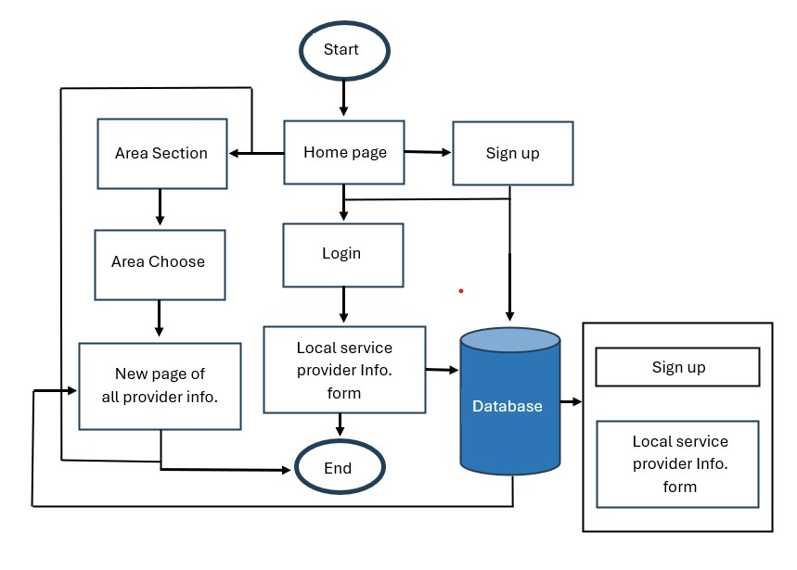

Figure 8.1 : Flowchart of Gearheads

7.1 Description of the design :
- Starting point : The process starts with a user initiating the process, likely by visiting the website.
- Sign up or Login : The flowchart splits into two options at this point. A user who already has an account can proceed to the login option. On the other hand, a new user will need to sign up for an account first.
- Sign up process : The flowchart shows that signing up requires the user to choose an area section and a homepage. It’s unclear what these sections represent exactly, but they could be related to the user’s location or preferences. After selecting these options, the user completes a local service provider information form. Once the form is completed, the user is directed to a new page that presumably displays all the service providers’ information.
- Login process : If the user already has an account, they can proceed to the login section.
- Local service providers information form : In this section all types of information about there shop will be provided through a form. They have to fill it so that there profile can be created in the website.
- New page of all providers information : All providers profile and there services will be shown in this page.
- End point : Once the user has either signed up or logged in, they’ve reached the end point of the flowchart, which signifies successful user access to the website.

8. Gantt Chart:
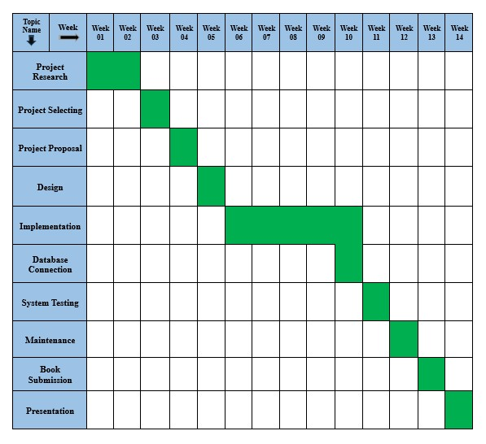

Figure 8.1 : Gantt chart of Gearheads

9. Maintenane:
Our proposed nationwide car servicing website offers a comprehensive suite of maintenance features designed to ensure optimal vehicle performance and longevity. Car owners can easily schedule routine maintenance services such as oil changes, tire rotations, brake inspections, and fluid top-ups. The platform utilizes vehicle data and driving patterns to create personalized maintenance plans tailored to each car owner's specific needs, ensuring that each vehicle receives the necessary care based on its usage.

10. Future Scope:
The future scope of a car servicing website is broad and includes several potential developments :
- Online Booking and Scheduling : Enhanced user interfaces for easy booking of services.
- Customer Relationship Management (CRM) : Improved tools for managing customer interactions and feedback.
- Automated Diagnostics : Integration with IoT devices for real-time vehicle diagnostics.
- Mobile Applications : Development of mobile apps for on-the-go service bookings and updates.
- Personalization : AI-driven personalized service recommendations.
- Digital Payments : Secure and diverse payment options.
- Green Initiatives : Services focused on eco-friendly vehicle maintenance.
These advancements can improve customer satisfaction, operational efficiency, and market reach.

11. Conclusion:
The future scope of a car servicing website is promising, with potential for significant advancements in various areas. Online booking systems can become more user-friendly, while CRM tools enhance customer engagement. The integration of IoT devices can offer real-time diagnostics, and mobile apps can provide convenience. AI-driven personalization can tailor services to individual needs, and secure digital payment options can streamline transactions. Furthermore, eco-friendly initiatives can align with the growing demand for sustainable practices. These advancements collectively enhance customer experience, operational efficiency, and market reach.

References:
[1]
Vehicle Management System, Volume 14. Author: Dr. C.K. Gomathy, Dr.V Geetha, K. Mallikarjun, Year: 2022
[Online] Available: https://www.researchgate.net/publication/363700029_THE_VEHICLE_SERVICE_MANAGEMENT_SYSTEM

[2]
Limited Accessibility,Verma, A., & Verma, R. , Year: 2015
[Online] Available: https://link.springer.com/

Litman, T. , Year: 2013. Accessibility and Mobility: Transportation Research and Analysis
[Online] Available: https://www.vtpi.org/

[3]
Transparency in Pricing , Oglethorpe, D., & Monroe, K. B. , Year: 2007 .
[Online] Available: https://journals.sagepub.com/doi/abs/10.1177/0022243720934863

[4]
Transportation Research Part C: Emerging Technologies , Aljohani, N. , & Murray , A. T. ,Year: 2007 .
[Online] Available: https://www.sciencedirect.com/journal/transportation-research-part-c-emerging-technologies

Karg, M., & Witzel, A. , Year: 2007.
[Online] Available: https://www.inderscience.com/jhome.php?jcode=ijatm

[5]
Car Maintenance research
[Online] Available: https://www.lithia.com/research/car-maintenance/index.htm

[6]
Google
https://www.google.com/

[7]
Youtube
https://www.youtube.com/

